Attention Teachers and Administrators!
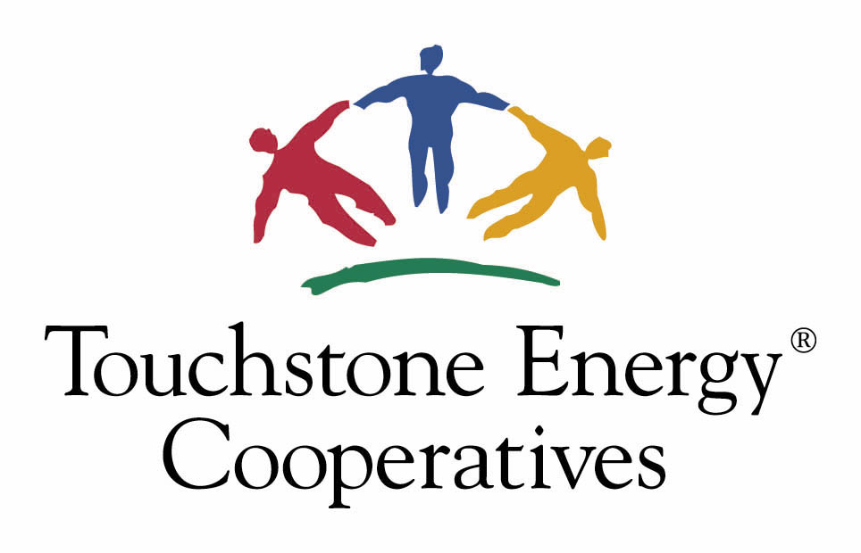
Have a project you’d like funded?

Touchstone Energy
Classroom Empowerment Grants

Enter Touchstone Energy’s Classroom Empowerment Grant Competition and your submission could win up to $1,000 to fund classroom and educational enhancement projects!

Touchstone Energy Classroom Empowerment Grants are being funded by SouthEastern Illinois Electric Cooperative (SEIEC) for the 2025-2026 school year. See the enclosed fact sheet for more information about Touchstone Energy or log on to www.touchstoneenergy.coop. To apply for a grant, send a double-spaced typewritten request (not to exceed 3 pages) that includes the following:

- A description of the project and what it will accomplish
- The estimated cost of the project
- An explanation of why outside funds are necessary to complete the project
- Whether funding options have been pursued, and if so, how
- When project will be completed
- The number of people affected by the project
- If the project’s goals are measurable, and how
- How the project ties in Touchstone Energy’s four core values of integrity, accountability, innovation and commitment to community

Photos and supporting data are optional. Grant applications must be received at SEIEC by November 7, 2025. For questions, please call SEIEC at (618) 273-3806 or e-mail Stefanie Tripp at stefanietripp@seiec.com. Entries will be evaluated by an impartial panel of judges. Awards will be announced on January 30, 2026.

